
Safeguarding Children
at St. Peter’s
No child should suffer harm, either at home or at school.
Everyone who works in or visits our school has a responsibility
to make sure that all our young people are safe.
Mrs Kelly – Headteacher (Lead DSL)
Mrs Hall- Deputy Headteacher (Deputy DSL)
Mrs McWilliams- Senior Teacher (Deputy DSL)
Mrs Walsh- Family Support Worker (Deputy DSL)

dsl@stpeters-leatherhead.surrey.sch.uk

Our school Designated Safeguarding Leads are:
Mrs Kelly Mrs Hall Mrs McWilliams Mrs Walsh
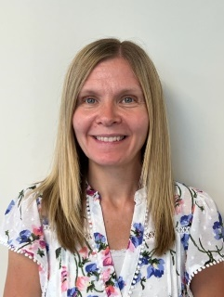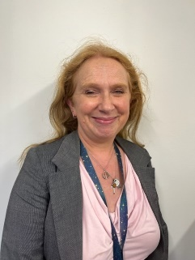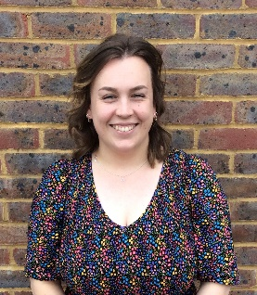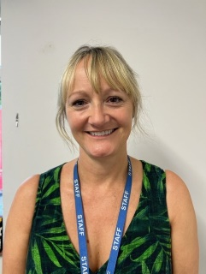

What should I do if I am worried about a child?
If you are worried about the safety of any young person in our school
for any reason, you MUST report this to one of our Designated Safeguarding Leads (DSLs).
You can speak to us in person, or contact us via email.
Also, if whilst working with, or talking to a child, you become concerned about:
- Comments made by a child
- Marks or bruising on a child
- Changes in the child’s behaviour or demeanour
Please report these concerns to one of the school Designated Safeguarding Leads.

