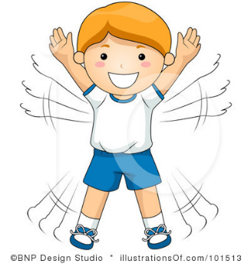
Which exercise makes you work the hardest?
Exercise to do for 1 minute | How did you and your body feel?
My answer:

