
SURREY COUNTY COUNCIL
DIOCESE OF ARUNDEL AND BRIGHTON
St. Peter’s Catholic Primary School

Handwriting and Presentation Policy

Mission Statement
At St Peter’s we are building Firm Foundations by…
Caring For Others
Achieving our best
Growing in Faith

At St Peter’s Catholic Primary School we believe that neat, well-formed handwriting and presentation of written work helps to raise standards as the pupils take pride in and have a sense of ownership of their work. As a school, we are adopting the Letter-Join style of joined handwriting as we feel this will ensure there is continuity between EYFS through to Key Stage 2.

Rationale
• Handwriting is a skill which, like reading and spelling, affects written communication across the curriculum. Through effective teaching, joined handwriting can be mastered by most pupils by the end of Year 2, enabling them, with practise, to go on to develop a faster and more mature hand.
• Handwriting is a fine motor movement skill and children need to practise handwriting movements correctly and often.
• The first handwriting lessons in Foundation Stage are vital and the most important issue is to ensure that the children we teach learn to form the letters of the alphabet with the correct sequence of strokes from the beginning and secure the correct pencil grip. We do not introduce cursive letters in YrR. We follow the sequence set out in Little Wandle Letters and Sounds Revised for teaching formation in YrR as well as the sequence in Letter-Join.

Aims
• To raise standards in writing across the school by ensuring a clearly structured, taught progression in handwriting and presentation skills.
• To raise expectations of children’s and adult’s handwriting and presentation skills.
• To adopt a common approach towards handwriting by all adults when writing in children’s books, on the whiteboard or on displays / resources.
• For pupils to:
• Achieve a neat, legible style with correctly formed letters which are joined for the vast majority of children by the time they leave Yr2.
• Develop flow and speed, so that eventually they can produce the letters automatically in their independent writing.
These aims will be delivered by:
Strategy for Implementation - Handwriting
Handwriting is taught regularly in every class through short, focused sessions and may be linked with spelling, grammar or phonic objectives. The teaching of handwriting may be undertaken as a discrete session, although shared and guided writing also provides additional opportunities for the modelling and monitoring of handwriting. However, handwriting is a cross curricular task and will be taken into consideration during all lessons.
Teaching and Learning
• Handwriting is a skill that needs to be taught explicitly. Since handwriting is essentially a fine motor movement skill, correct modelling of the agreed style by the teacher and learning assistant is very important.
• Children will use a variety of mark making tools but when formal handwriting lessons take place handwriting pencils / pens will be used.
• It is not sufficient to require pupils to just copy models from a published scheme or worksheet.
• Consistency in the attitudes displayed, the methods employed, and the models provided is the key to effective learning.
• A mixture of whole class, small group and individual teaching is planned.
The role of the Teacher and Learning Assistant:
• To follow the school policy to help each child develop legible and fluent handwriting.
• To provide direct teaching and accurate modelling.
• To provide resources and an environment which promotes good handwriting.
• To observe pupils, monitor progress and determine targets for development.
• To correct letter / number formation as early as possible to prevent poor handwriting habits becoming embedded. (All members of staff, including teaching assistants, supply teachers and children are provided with appropriate handwriting models and are expected to promote the agreed handwriting style by their own example).

Correct posture and pencil grip for handwriting Pupils should be taught to sit correctly at a table, holding a pencil comfortably and correctly.
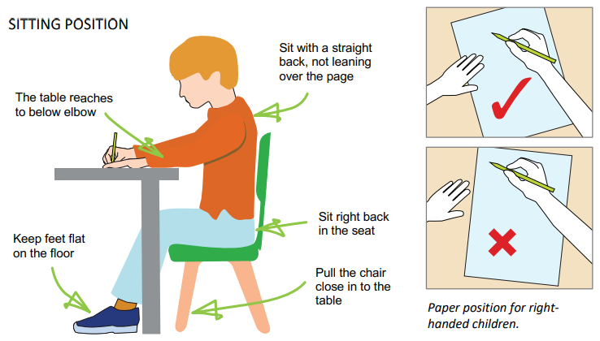

Reception
• The emphasis at this stage is with movement rather than neatness. Letter formation (starting at the right entry point and then moving in the right direction) learned at this early stage becomes automatic and has a profound influence on later fluency and legibility.
• To aid movement, close attention is given to pencil grip, correct posture, the positioning of the paper and the organisation of the writing space. Teachers are vigilant to ensure that bad habits do not become ingrained and that the specific needs of left-handed pupils and those with special educational needs are met.
• In the pre-communicative stage pupils play with writing and these experiments are recognised and praised as an important stage in the child’s understanding that marks on paper convey meaning.
• Pupils are given the opportunity to experiment with a range of writing materials and implements. A multi-sensory approach, including Write Dance and pattern making activities and Clever Fingers, are used to help pupils develop writing-readiness.
• Tracing over /under patterns and shapes are an important stage of development.
• Children should also spend time making large marks and the sizes should decrease as they become more accurate with their mark making.
• Letters are taught in families with rhymes as appropriate and are linked to the order in which graphemes are learnt in Little Wandle Letters and Sounds Revised. (Appendix 1)
• A focus will be on writing their own name.
• Letters should be formed correctly, and children should leave spaces between words, form capital letters and begin to use where appropriate. Children should also be taught to form numerals that are consistent in size and orientation.
• The focus throughout Term 1-4 is lowercase letter formation. We teach capital letters as and when they come up e.g. in names and titles of books. We teach the formation of all capital letters in the summer terms (5-6).

Key Stage 1 and 2 Handwriting
• Building on the Foundation Stage, pupils at Key Stage 1 develop a legible style and begin to join their letters at the end of Year 1. This is dependent on the physical ability not age of the child. This is normally achieved in Year 2 by developing a comfortable and efficient pencil grip and by practising handwriting in conjunction with spelling and independent writing. If the child would benefit from making large marks, tracing over, copying under and pattern making then provision must be made for this.
• Correct letter orientation, formation and proportion are taught in line with the school’s agreed handwriting style.
• Children will write legibly using upper and lower-case letters with correct orientation.
• Letters should sit on the baseline and be consistent in size with ascenders and descenders that are the correct length and formation.
• Children should continue to leave spaces between words, form capital letters and use them where appropriate. They should also be able to form numerals that are consistent in size and sit on the base line.
• Children will improve the speed of writing and begin to write automatically thus promoting creativity in their independent writing. Formal teaching of handwriting is to be carried out regularly and systematically and a developmental approach is used to move children through the phases, being mindful of end of Key Stage expectations if additional support via interventions is needed.

Inclusion
For children who experience handwriting difficulties due to fine motor development, including those who are left-handed and those with special educational needs, the appropriate additional support will be put into place. Some pupils need more support and a specific individual or group programme is drawn up in consultation with the SENCO. Thicker triangular pencils, pencil grips and wider lines will be used by children experiencing problems with writing alongside other activities to develop their fine motor skills. All teachers are aware of the specific needs of left-handed pupils and make appropriate provision. Letter-join’s Lesson Planners all include differentiation activities for extra practice/challenge. Handwriting at Home Pupils are encouraged to practise their handwriting at home by using the Pupil log-in for Letter-join. Teachers will set specific tasks such as:
• Magic Patterns
• Magic Words
• PhonicsMatch
• Word Search
• Word Bank
• Write it Right!
Children can also watch the word and letter animations and practice and explore other handwriting resources on Letter-join.

Left-Handed Children
Left-handed children may find it difficult to follow the movements of right-handed teachers as they model letter formation (and vice versa). Teachers should demonstrate to left-handers on an individual or group basis. • Left-handed pupils should sit to the left of a right-handed child so that they are not competing for space.
• Pupils should position the paper/book to their left side and slanted, as shown.
• Pencils should not be held too close to the point as this can interrupt pupils’ line of vision.
• Extra practice with left-to-right exercises may be necessary before pupils write left-to-right automatically.
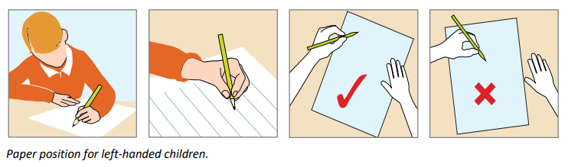
Presentation
It is essential that all children should have pride in their work and that it is set out well.
• At Key Stage 1 and 2 children will begin new work on a new page each lesson as appropriate for ability.
• Teacher's comments or symbols will indicate whether a correction needs to be addressed.
• In Key Stage 2 erasers will not be used to correct pencil work – children should either draw a line through the mistake with a ruler OR put a cross next to the incorrect work.
• Criteria for presentation of work will be discussed with the children prior to commencement of work.
• Any pictures should be coloured in with colouring pencils. Felt-tip pens should not be used in exercise books.
• Rulers will always be used where children need to draw lines.
• Children will be reminded to take care of their book and present their work neatly.

English, RE Science, History, Geography Presentation
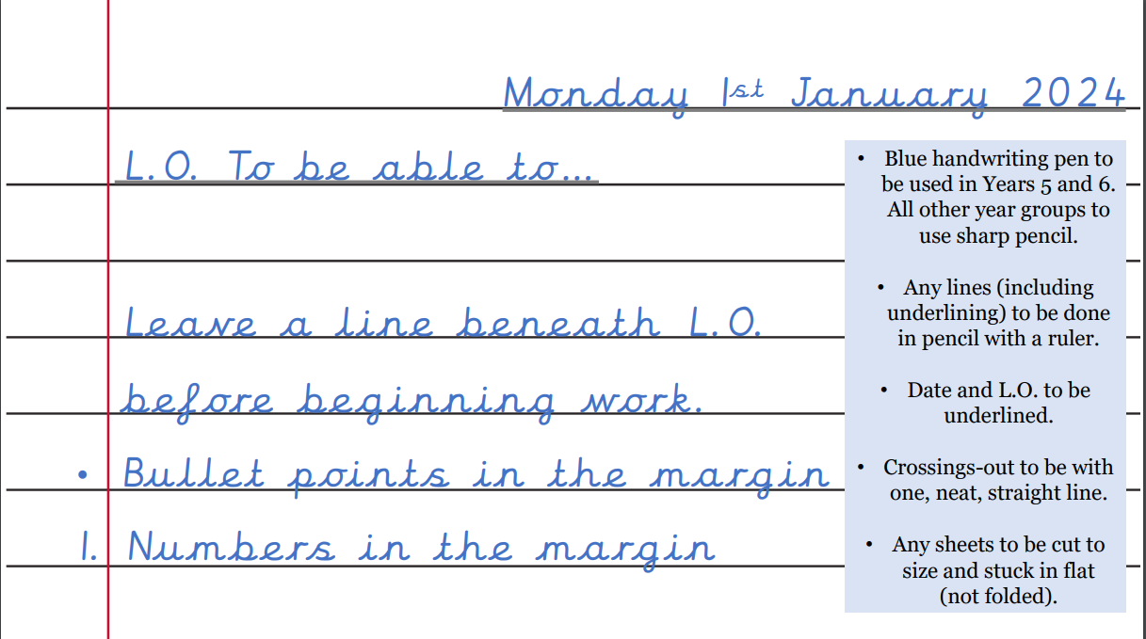
Maths Presentation
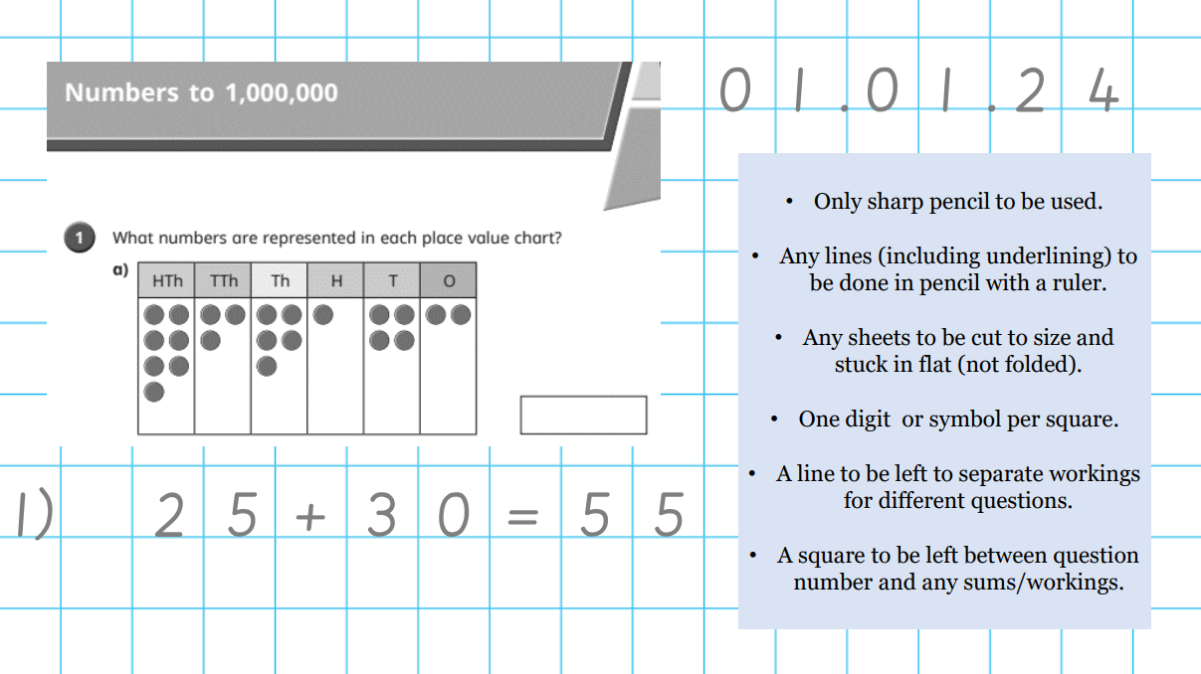

Resources
To aid pupils’ handwriting we have purchased a site licence for Letter Join and for the handwriting font. This is loaded onto all computers in the school. These resources can also be used on interactive whiteboards to model letter formation.

The Learning Environment
• A dedicated writing area is established in all Reception classrooms so that writing resources are centrally displayed.
• Writing areas/boxes are equipped with a range of writing implements and materials.
• Throughout both key stages teachers display both handwritten and word-processed work to give a high profile to developing a neat, legible cursive style.

Monitoring and Evaluation
- This will be undertaken by the class teacher and will also be assessed as part of each term’s literacy independent writing assessments.
- When undertaking work scrutiny subject leaders will monitor all subjects for neat presentation and legible, accurately formed handwriting.
- The English Leader will monitor that handwriting is taught, practised and modelled throughout the school.
- This policy will be reviewed every two years.

Policy Date: February 2024
Review Date: February 2026

Appendix 1 - Little Wandle



