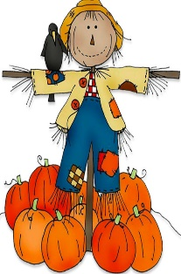
RE
Our topics following the new RE curriculum are Creation & The Covenant where we revisit the story of Creation. We are made in the image of God and given the task of caring for the Earth. In the topic of Prophecy & Promise we explore the mass-what happens and how it links to scripture. We also prepare for the important season of Advent.
Elm & Birch
2025 – 2026
Autumn Term
Curriculum Overview
Maths
This term we will be beginning our Year 3 learning using White Rose Maths. The topics we will cover include; place value and the four operations (addition, subtraction, multiplication and division).

PE
Our outdoor PE will focus on balance and movement. Indoor PE for this half term will be focused on dance and gymnastics.
Guided Reading
Our first guided reading text will be ‘The Owl Who Was Afraid of The Dark’ which we will read in our class time daily as well as non-fiction articles and poems. Reading: Children should continue to read aloud at home every day. Please ask your children questions about what they have read to check their understanding.
Science
This term, we will begin with our topic of ‘Animals including Humans: Movement and nutrition’ where children will explore their bodies and the need to stay healthy.
After, we will move on to our topic of ‘Rocks and Soil’.
English
Year 3 children will be developing their reading and writing (including punctuation, spelling and grammar) which are sometimes linked to our guided reading texts and topics.
The main skills taught this term are:
- Capital letters and full stops
- Noun phrases/expanded noun phrases
- Fronted adverbials
- Punctuation (apostrophes, commas in lists)
- Adventurous vocabulary
Spellings: Given out on a Friday – Test on the following Friday.
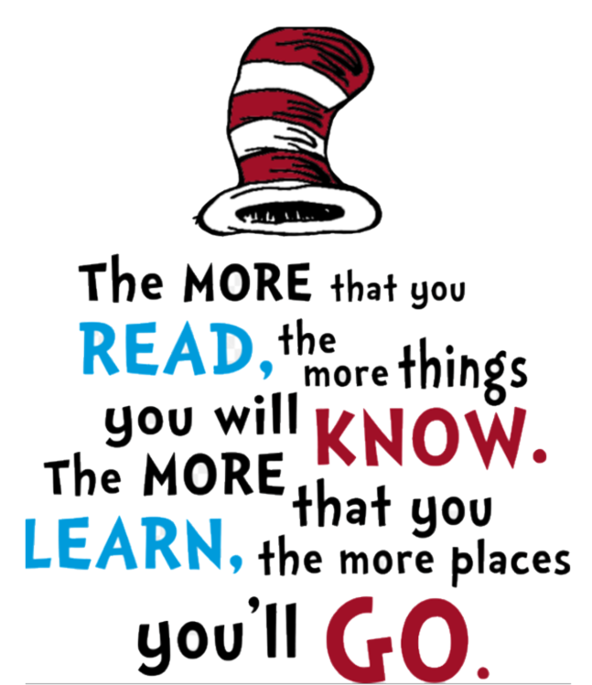
Computing
We will begin by revisiting important areas of online safety, focusing on how to keep ourselves safe as we become increasingly independent. Later on, we will learn about Computing Systems and their Networks with a focus on connecting computers and improving our basic computing skills using the Chrome Books. Scratch coding will also be a focus.
Art and Design
This term we will be linking our Art and Design to our topic work. We will be exploring using a variety of techniques and materials to create cave paintings as well as many other creative masterpieces.
In DT, we will link to our Science Topic of nutrition and be learning about how we can eat seasonally.
Topic
History
This term, we will start our learning with our History topic of ‘the Stone Age, Bronze Age and Iron Age.’
Geography
After our History topic, we will move on to our Geography topic of ‘Why do People live near volcanoes?’

PSHE
As we start the year, our focus will be on developing confidence, independence and resilience. Lots of our PSHE learning is child-led and we choose topics which are relevant to the children which we will explore during circle time, assemblies and other cross-curricula links – such as computing.

