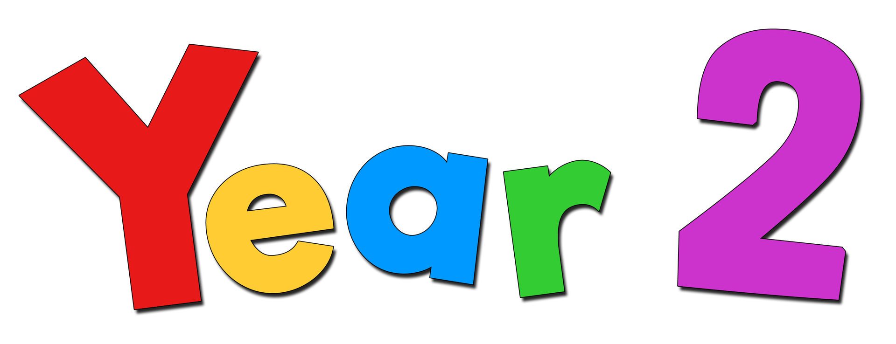
English:
Writing: This term we are going to read “A Boy, his Dog and the Sea” by Anthony Browne. We used this to inspire writing a letter that described a drama happening at the beach. We will create a fact file on how plants grow. We will also use ‘The Tiny seed’ by Eric Carle to inspire us to write instructions.
Key skills: We are going to be focussing on using co-ordination (e.g. or/ and / but) and subordination (e.g. when / if / that / because) in our writing
Capital letters and full stops. Cursive handwriting and applying spelling rules
Punctuation (apostrophes, commas in lists, question marks and exclamation marks)
Sentence openers, verbs, adverbs and adjectives.
We will be learning further spelling rules from our scheme on Ed Shed whilst also continue to practise our Year 2 common exception words.
Guided Reading: We are continuing to develop our reading prosody whilst also exploring a variety of texts. We will begin by exploring the story

Maths
This term we will be covering a variety of topics in maths and continuing to revise our mental arithmetic skills. We will begin with learning about fractions, where we will recognise a half, a quarter and three quarters in a shape and in number. We will then move onto time, recognising telling the time up to minutes to and minutes past. Within each topic we will explore reasoning and problem-solving skills so that all children can practise applying new concepts.

Computing
We will be learning to collect, input and interpret data on a spreadsheet. We will so be learning how computers are used in the wider world.

Art
This term we will explore manipulating shape and mark making first with playdough and then clay. We will then create a clay pinch pot. We will next design and make a clay tile with features inspired by plants.

- Roll a smooth tile surface.

- Join clay shapes and make marks in the tile surface to create a pattern.

Geography
We are learning about what it is like to live by the coast? We will be working up to visiting and collecting data on human features and how people use the coast. We will be going to Littlehampton. We will look at coasts across the UK and use digimaps to look at physical features.

PE We will be involved in invasion games which involve attacking and defending. To develop skills and strategies, including how to gain possession.

RE
We will learn about the symbolism of light and dark in the Easter Vigil. We will learn about Jesus appearing to the apostles and his Ascension. We will also learn about Pentecost the conversion of Saul and the fruits of the Holy Spirit

Science
We will learn what a healthy plant needs to grow. We will recognise that light, water and warmth are needed. We will sequence the lifecycle of a plant and describe the influences humans have on plants in the environment. As part of this we will be doing lots of planting both inside and outside the classroom.
Summer 1

