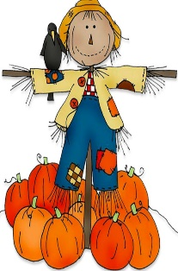
RE
As in previous years, this term, we will continue to follow our RE Curriculum. We will deepen our understanding of scripture and faith.
Our topic titles for this term are:
Creation and Covenant-exploring the Creation Story in Genesis
Prophecy and Promise-exploring the Annunciation of Joseph
Elm & Birch
2026
Autumn Term
Curriculum Overview
Maths
This term we will be beginning our Year 3 learning using White Rose Maths. The topics we will cover include; place value and the four operations (addition, subtraction, multiplication and division).

PE
Our indoor PE for this half term will be focused on football.
Guided Reading
Our first guided reading text will be ‘The Owl Who Was Afraid of The Dark’ and then continue to explore poetry and information texts which we will read in our class time daily. Reading: Children should continue to read aloud at home every day. Please ask your children questions about what they have read to check their understanding.
Science
This term, we will begin with our topic of ‘Animals including Humans: Movement and nutrition’ where children will explore their bodies and the need to stay healthy.
After, we will move on to our topic of ‘Magnets and Forces’.
English
Year 3 children will be developing their reading and writing (including punctuation, spelling and grammar) which are sometimes linked to our guided reading texts and topics.
The main skills taught this term are:
- Capital letters and full stops
- Noun phrases/expanded noun phrases
- Fronted adverbials
- Punctuation (apostrophes, commas in lists)
- Adventurous vocabulary
Spellings: We will learn the spelling rules allocated to Year 3, as well making sure all high frequency words are spelt correctly.
Spellings: Given out on a Friday – Test on the following Friday.
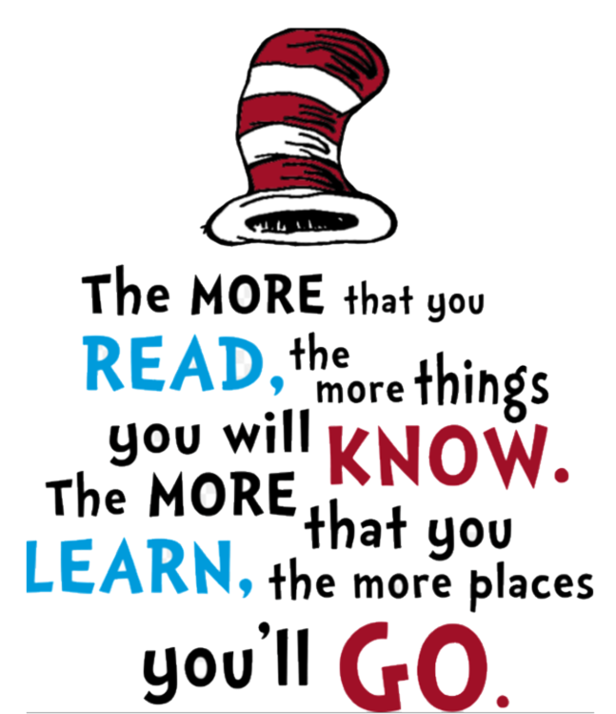
Art and Design
This term we will be linking our Art and Design to our topic work. We will be exploring using a variety of techniques and materials to create prehistoric art as well as many other creative masterpieces.
In DT, we will link to our Science Topic of nutrition and be learning about how we can eat seasonally.
Topic
History
This term, we will start our learning with our History topic of ‘the Stone Age, Bronze Age and Iron Age.’
Geography
After our History topic, we will move on to our Geography topic of ‘Why do People live near volcanoes?’

General Reminders:
• Spelling Tests on Friday (Spellings given on Fridays)
• Homework is given on Fridays and due in the following Friday
• PE Days: Monday +Tuesday
RSHE/PSHE
As we start the year, our focus will be on developing confidence, independence and resilience. Lots of our RSHE/PSHE learning is child-led and we choose topics which are relevant to the children which we will explore during circle time, assemblies and other cross-curricula links – such as computing.

Computing
We will begin by revisiting important areas of online safety, focusing on how to keep ourselves safe as we become increasingly independent. Later on, we will learn about Computing Systems and their Networks with a focus on connecting computers and improving our basic computing skills using the Chrome Books.

